**EXP NO3 CAR RESERVATION SYSTEM**

**AIM:** Create a simple cloud software application for Car Reservation System using any Cloud Service Provider to demonstrate SaaS.

**PROCEDURE:**

**step1:** Go to zoho.com.

**step 2:** Log into the zoho.com.

**step 3:** Select one application step.

**step4:** Enter application name as Car Booking Reservation System.

**step 5:** Created new application as Car Booking Reservation System.

**step 6:** Select one form

**step 7:** The software has been created.

**IMPLEMENTATION:**

**STEP1: GOTO ZOHO.COM**

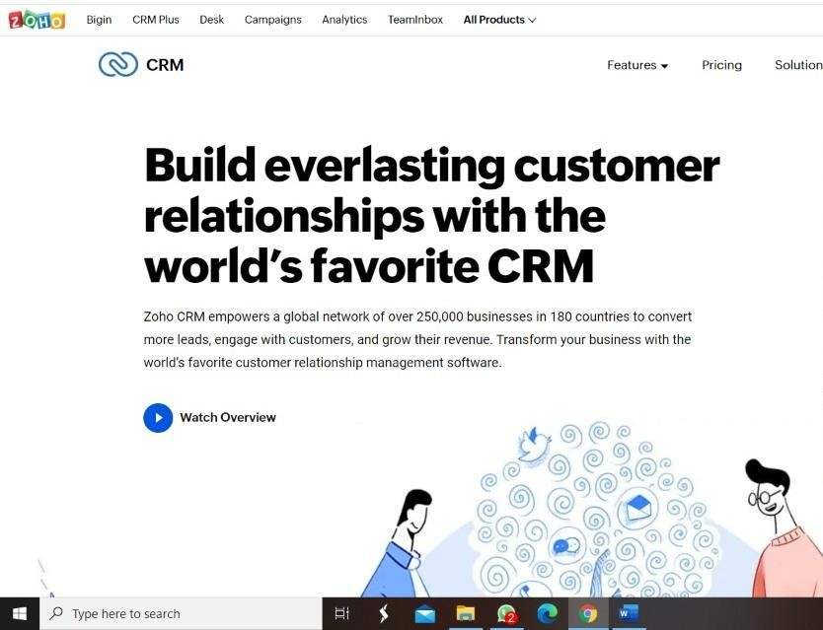

**STEP 2: LOGINTOTHE ZOHO.COM**

**STEP 3: SELECT ONE APPLICATION**

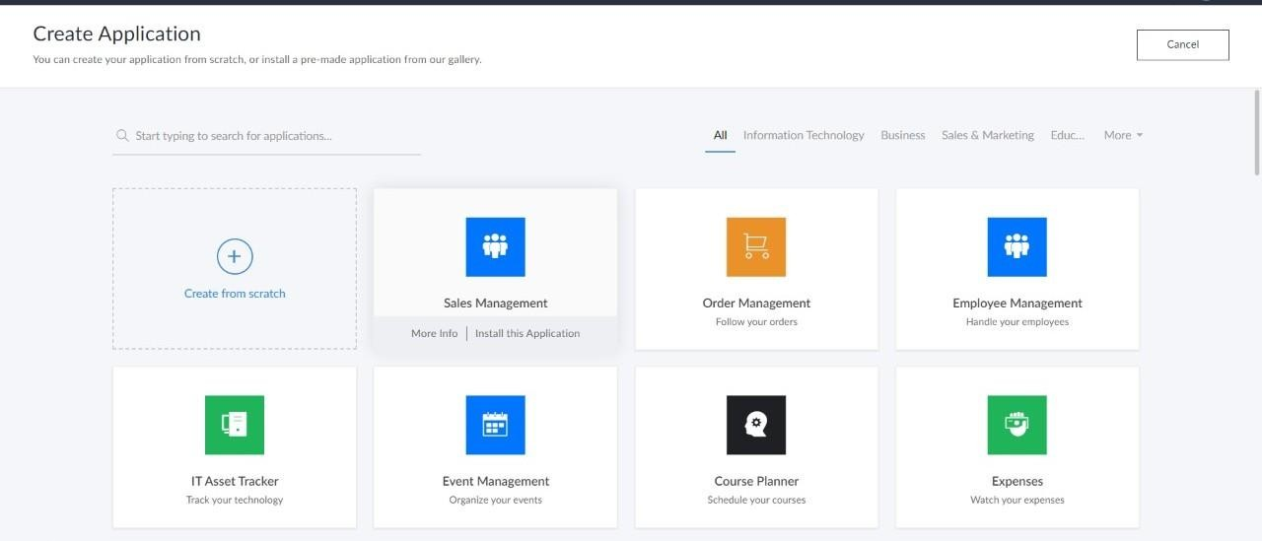

**step4:** Enter application name as Car Booking Reservation System.

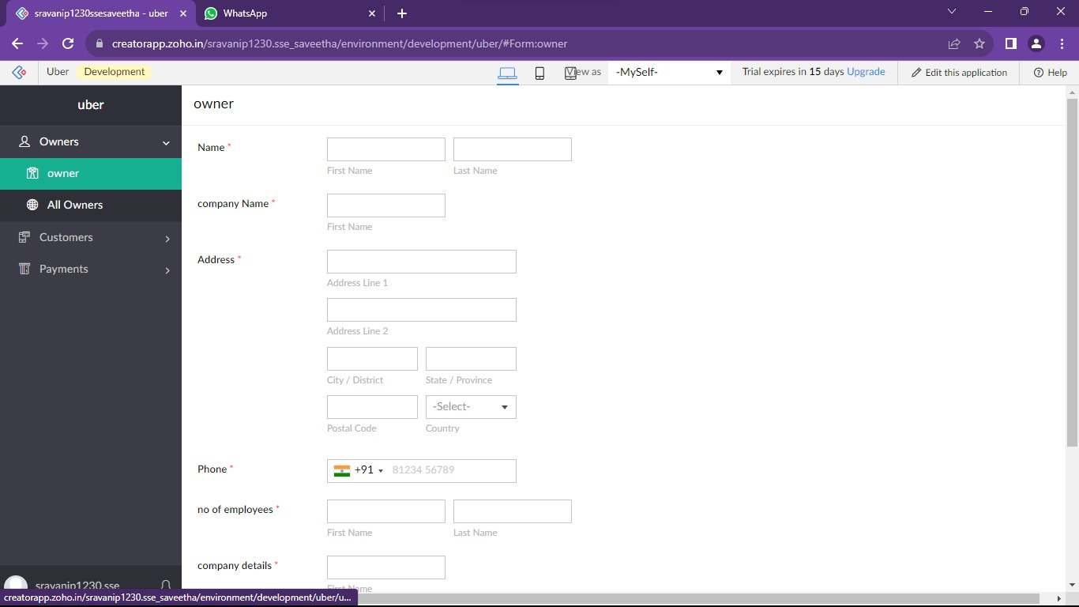

**step 7:** The software has been created.

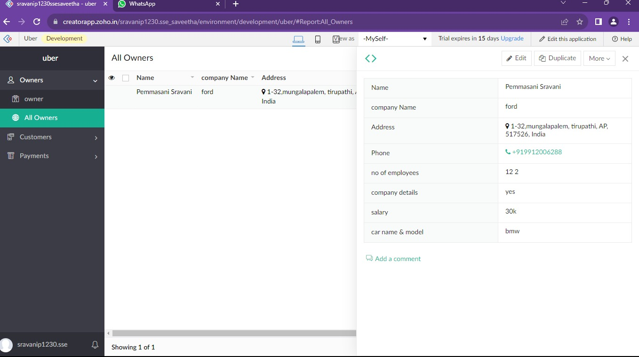

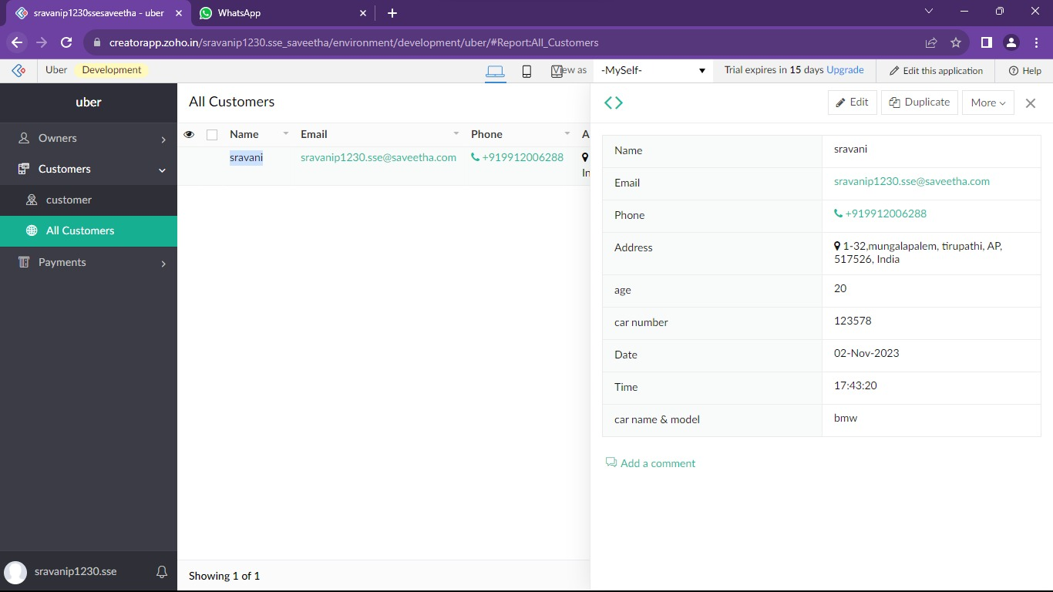

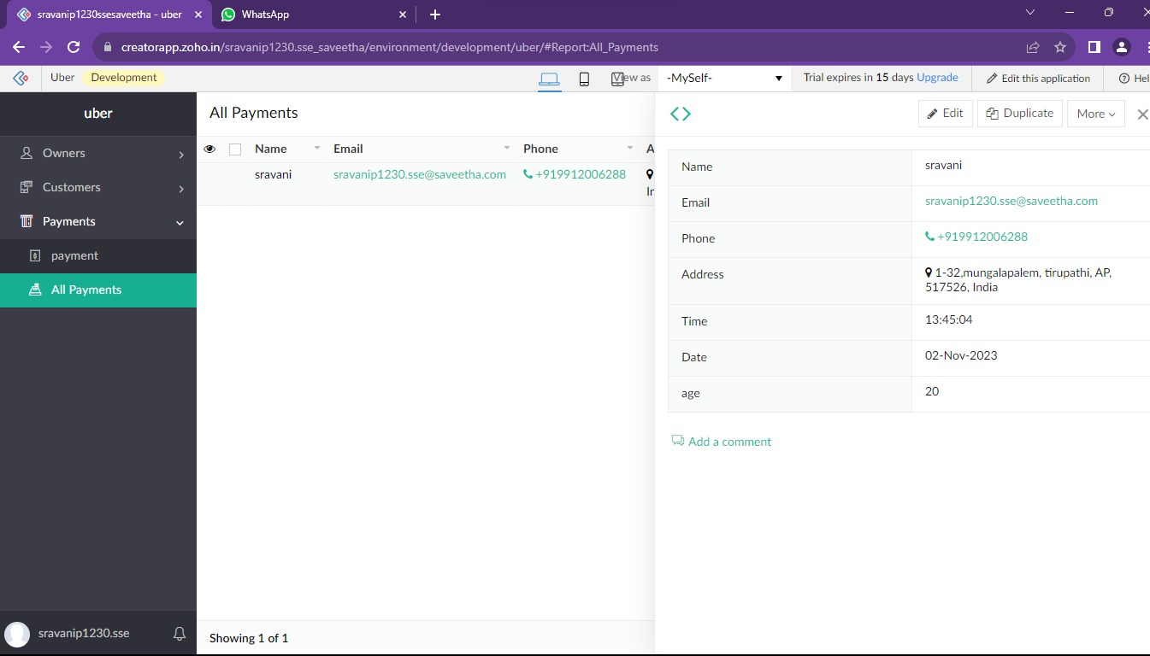

**Result:**

Successfully Developing a car reservation system with Zoho ensures scalable, secure, and integrated solutions for seamless user experiences**.**